Geomorphology 250 (2015 ) 15-28
Contents lists available at ScienceDirect

Geomorphology

journal homepage: www.els e v ie r . c o m / lo c a t e / g e o m o r p h

Bedload transport in a river confluence
J.P. Martín-Vide, A. Plana-Casado, A. Sambola, S. Capapé *
Technical University ofCa talonia-BarcelonaTech, Barcelona, Catalonia, Spain

CrossMark

ARTICLE INFO

Article history:
Received 6 April 2015
Received in revised form 13 July 2015 Accepted 15 July 2015
Available online 10 August 2015

Keywords:
Bedload
Conlluence morphodynamics Gravel-bed river
Sediment transport
ABSTRACT

The confluence ofthe regulated Toltén River and its tributary the unregulated Allipén (south ofChile) has proved dynamic in the last decade. Daily bedload measurements with a Helley-Smith sampler, bed surveys, and grain­ size distributions of the two rivers are obtained from a field campaign that lasts 3 months in high-flow season. The goals are to quantify total bedload and to understand the balance between tributary and main river and the bedload distribution in space and texture. The bedload transport varíes 200-fold, with a maximum of 5000 t/day. The discharge varíes five-fold, with a maximum of 900 m³/s. Two-thirds of the total bedload volume are transported through the deeper area of the cross section and grave! is predominant (64 %). Average bedload vol­ umes in the confluence seem unbalanced in favourof the tributary. Main river bedload transport is predominant­ ly at below-capacity conditions, while the tributary bedload transport is at-capacity conditions. This is deemed the main reason of inaccuracy of the bedload predictors. The roles of entrainment into suspension, helical flow, partial transport, and mobile armour are discussed .

© 2015 Elsevier B.V. Ali rights reserved.

lntroduction

River Toltén originates in the Andes and flows toward the Pacific Ocean through the regían of Araucanía in the south of Chile ( Fig. 1 ). A run-of-river hydropower plant is projected for the river, consisting of a low-head cross-river weir equipped with sluice gates anda canal in­ take in the right bank. The weir location, directly downstream of a con­ fluence, will allow the runoff of the tributary and main river basins to be used (a total drainage area of 5700 km ²) . The main river and the tribu­ tary are gravel-bed rivers. The planform ofthe river at the confluence is highly dynamic. These facts raised concerns on whether sand, grave!, or even coarser material transported by both rivers could clog the intake of the future hydropower development and result in costly maintenance needs to keep the intake free of sediment. The high uncertainty associ­ ated with sediment transport computations warranted a field campaign during the feasibility phase of the project. The study focused on bedload transport because, essentially, a partía! barrier such as a low-head weir would not obstruct the suspended load. The opening of the sluice gates at the future weir would partially purge the coarse material, but dredg­ ing would likely be required to deal with the remaining sediment. Detailed knowledge of bedload transport is critica! to assess the risk of clogging of the intake and to estímate dredging needs. This paper pre­ sents the results of the field campaign conducted in 2013 to quantify the total bedload at the location of the planned facility.

- Corresponding author at: Technical University of Catalonia-BarcelonaTech. e/ Jordi Girona 1. D1-204. 08034 Barcelona, Catalonia, Spain.
E-mail address: sergi.capape@upc.edu (S. Capapé ).
In addition, given that data on bedload transport in river confluences are scarce, the new data and the past and present river morphology at the confluence are analysed in arder to obtain a deeper understanding of the system.
Fluvial dynamics at the confluence of two streams have attracted considerable attention in the last three decades. Scale models ofbraided rivers (Ashmore and Parker, 1983 ) and laboratory experiments of the junction of rectangular channels ( Biron et al., 1996; Qing-Yuan et al., 2009 ) have resulted in the identification of severa! hydro- and morphodynamic features such as a shear !ayer that forms along the junction ofthe two streams; a separation area, caused by the deflection of the tributary, prone to create a bar; a bed discordance (i.e., the tribu­ tary bed elevation is higher than the main river bed elevation) that ends in an avalanche face; and a scour hale that appears downstream of the crossing of the tributary and main river alignments ( Fig. 2). Numerical models have been tested in the particular conditions of a river conflu­ ence ( Lan e et al., 2000; Roca et al., 2008 ). A prevailing objective of re­ search has been to identify the factors that control the depth and location of scour hales . Sorne of the studied factors are the confluence angle, the discharge ratio (defined as the ratio of the tributary discharge over the main river discharge), and the bed discordance.
Because of the difficulties associated with the extrapolation of labo­ ratory results to real cases, field investigations are becoming an increas­ ingly popular too! in the study of confluences ( Parsons et al., 2007). At first, the insight gained through experimentation was used to interpret real case studies for which limited measurements were available (Best, 1987, 1988 ). Unfortunately, most of the case studies forwhich extensive field data are available deal with creeks and small rivers ( Roy and Bergeron, 1990; Rhoads, 1996; Leclair and Roy, 1997; Rhoads and

http ://dx.doi.org/10.1016/j.geomorph.2015.07.050 O169-555X / © 2015 Elsevie r B.V. Ali rights reserved.

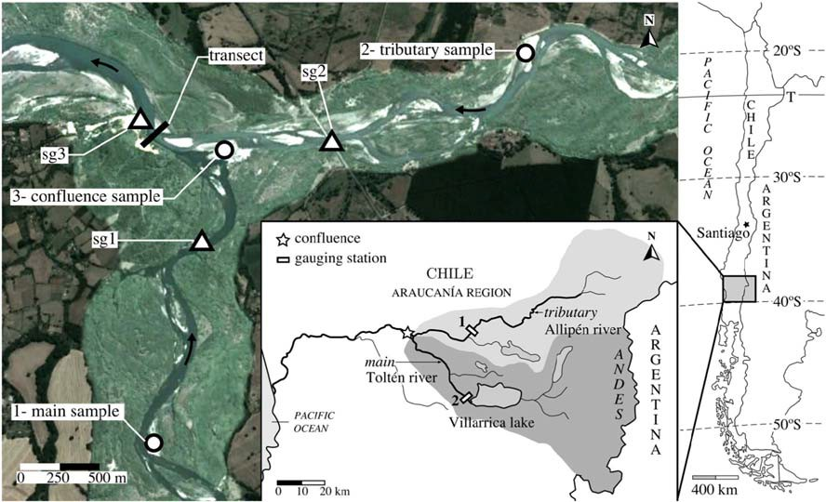

Fig. 1. General view of the study area: the conlluence of the Toltén (main river) and the Allipén (tributary), the position of the statT gauges (sgl, sg2, and sg3), and the locations of the collected bed material samples. StatT gauge sgl was secured to a rock ofthe left river bank, sg2 to a bridge pillar, and sg3 to the rock outcrop that dominares the plain. The distances be­ tween sg2 and sg3 and between sgl and sg3 are 1425 and 1326 m, respectively, along the river course. Insert: location map with che two subbasins and the Chilean Water Agency gauging stations.

I<enworthy, 1998; Rhoads and Sukhodolov , 2001, 2008; Best and Rhoads, 2008). A noteworthy exception is the Paraná River, a large braided system with multiple confluence-diffluence units ( Parsons et al., 2007, 2008). Research has been focused primarily on flow struc­ ture ( Rho ads and I<enworthy, 1998 ), including secondary currents (Rile y and Rhoads, 2012) and turbulence ( De Serres et al., 1999 ). To a lesser extent, bed morphology has also been the object ofvarious field studies ( Rhoads et al., 2009; Riley and Rhoads, 2012 ), together with particle-tracking studies to understand the sediment trajectories ( Best, 1988; Roy and Bergeron, 1990). Nevertheless, actual sediment transport measurements in river confluences are very limited ( Rhoads, 1996; Boyer et al., 2006) and are lacking for large gravel-bed rivers.
Bedload transport within confluences has been identified as a big gap and a fertile ground for research (Be st and Rhoads, 2008 ). In addi­ tion, this confluence is a medium to large gravel-bed river system

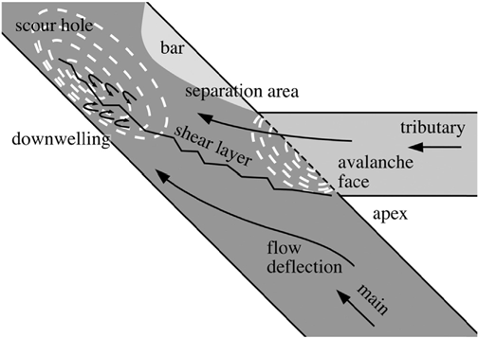

Fig. 2. Sketch of hydro- and morphodynamic features observed in a river conlluence. Source: adapted from the literature.
with a bankfull discharge of about 1000 m³/s. Five connected topics are treated: (i) the balance between tributary and main river contribu­ tions to total bedload, (ii) the spatial distribution ofbedload across the river channel, ( iii) the grain-size distribution of bedload in comparison with the river grain sizes, ( iv) the performance of predictors that com­ pute bedload by grain-size fractions, and (v) the conditions at which bedload is transported, either at-capacity or below-capacity or, in other words, the conditions at which it is controlled either by capacity or by supply. These research objectives were compatible with the re­ quest of quantifying the total bedload arriving at the planned facility. The request provided an opportunity to better understand the bedload transport, which serves as a link between confluence flow and bed mor­ phology at the confluence, even with limited hydrodynamic measure­ ments. The need to include different mechanisms to account for the field results in the discussion may be a novel aspect.
For the purpose of this paper, two minor remarks are retained from the literature review: (i) the bed discordance reduces the main river flow deflection (Biron et al., 1996 ) and (ii) a high tributary over main river discharge ratio narrows the scour hole and pushes it toward the main river bed, hampering the entry of much of the bedload ( Best, 1988; Rhoads et al., 2009 ).

Description of the study area

Ninety-five kilometres befare flowing into the ocean, atan elevation of 105 m above sea leve! (asl ), two large streams join: the Toltén itself (i.e., the main river), naturally regulated by Lake Villarrica, and the trib­ utary Allipén, which runs mostly unregulated. The drainage areas at the confluence are 2500 km² for the unregulated tributary and 3200 km ² for the regulated main river ( Fig. 1 ). The confluence is located in a flat allu­ vial area dominated by a single rock outcrop that protrudes into the river from its left bank shortly downstream ofthe confluence ( Fig. 3 ). The outcrop is the only conspicuous geological controlling factor on the stream planform, and it forces the river to turn sharply to the right. The rock outcrop offers a solid left buttress for the planned weir. In the study area the tributary has a wandering planform, while the

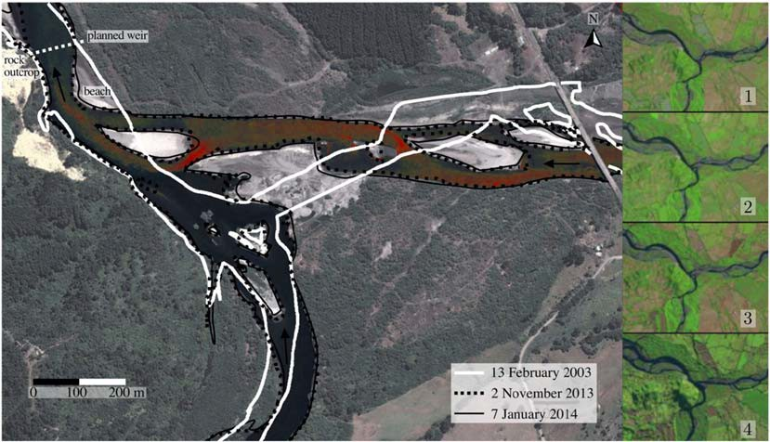

Fig. 3. Outlines of the river confluence in February 2003, November 2013, and January 2014 drawn from aerial photographs. The latter corresponds to the background image. Only the water has been colour-altered to highlight the difference between the tributary and the main river. ln set: satellite images 1 through 4 dated January 2008, December 2008, February 2009, and July 2009, respectively. Note the images comprise different river stages. The majar impulses occur between pictures 1 and 2 and between pictures 3 and 4. (Far interpretation ofthe references to colour in this figure legend, the reader is referred to the web version ofthis article.)

main river is rather a single-thread meandering river. The slope of both streams in the area is -0.2%. Downstream from the confluence, the main river tums into a wandering river similar to the tributary and exhibits emerged grave! bars, with rifles and pools forming in the main branch and in sorne minar branches.
Bathymetric surveys of the river bed were carried out in June and July 2013 using an echo sounder deployed from a small boat ( Fig. 4 ). The wide and shallow river confluence fashions an arrow-like peninsula that describes a 30º angle, expands under water, and separa tes the trib­ utary and the main river. The peninsula lengthens or shortens with a de­ crease or increase ofthe flow rate, respectively. In sorne cases, the tip of the peninsula forms an island (e.g., compare Figs. 3 and 4). The bed ele­ vation difference between the tributary (higher) and the main river
(lower) translates into a discordance of -3 m, measured 200 m up­ stream of the intersection of the river axis. Accordingly, the water depth along the tributary axis drops severa! metres, abruptly forming an avalanche face at the confluence. Farther upstream (in the region of the bottom-right comer of Fig. 4 ), the bed of the main river also pre­ sents a milder avalanche face.
The tributary alignment impinges on the rock outcrop, whereas the main river alignment is only slightly deflected by the outcrop. From re­ mark (i) in the previous section, the deflection occurring in any conflu­ ence is superimposed to the deflection forced by the rock outcrop in this case study. The stream narrows noticeably at the outcrop where maxi­ mum depths are recorded. A thin, elongated scour hole extends from this location to farther upstream along the left river bank. According

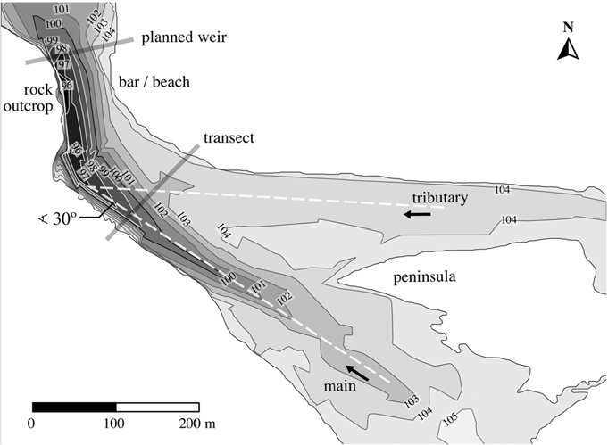

Fig. 4. Bathymetry of the confluence area in the period of June-July 2013. The locations of the projected weir and the transect mark the study section.

to remark (ii) in the previous section, the scour at the confluence, which suggests a high tributary over main river discharge ratio, is superimposed to the bend scour.
Befare reaching the confluence, the main river flows northward and the tributary flows westward ( Fig. 1 ). During the field campaig n, the junc­ tion was an - 30º angle. The planform ofthe confluence was substantially different in 2003 compared to 2013 ( Fig. 3 ): the two streams merged con­ siderably upstream, the tributary flowed toward the southwest, and the main river alignment was more tangential to the rock outcrop ( the streams described a 70º anglejunction). Small islands appeared between the two streams. A major shift in alignment of the tributary shaped the current península of 2013. The confluence evolution was tracked through a set of low-resolution satellite images that show the high dynamicity of the site (inserts in Fig. 3 ). Although relatively gradual, the shift can be dated between January 2008 and July 2009 in two impulse s, and it dem­ onstrates a highly dynamic confluence in the past.
In the sector of interest, a sandy point bar with no vegetation (also labelled beach) emerges in low flow at the right bank. This point bar, which is consistent with the separation area at the confluence, may have formed at the same time as the península when the alignment of the tributary shifted in 2008-2009 ( Fig. 3 ). Sand transport is observed in this shallow area. In contrast, the rock outcrop dominates the left bank. The outcrop extends steeply underwater, causing high water depths in the left side of the river. In the study area, the river can thus be described as the combination of two parts: a deep area on the left and a shallow area on the right. This division has a great impact on local bedload transport.
Addition ally, in the area immediately adjacent to the left river bank, water is stagnant and even slightly swirling. During high-flow episodes, floating debris arrives to the confluence through the tributary and heads to this area, where in many cases they get trapped. This is significant as an overall flow pattern. Moving toward the right side, the flow increases drastically in deep water and then decreases again in the shallow area adjacent to the right bank bar.
Finally, Fig. 3 suggests that the tributary carries more suspended load than the main river (note the red in the colour-altered aerial pho­ tograph). The colour difference remains visible along the mixing area ( i.e., the shear !ayer), where the reddish waters of the tributary are spreading and almost come into contact with the left bank of the river. The debris trajectory and the tributary spread are signs of an outward near-surface flow and implies sorne downwelling anda corresponding inward near-bed flow consistent with the development of helical mo­ tion ( Rhoads and Kenworthy, 1998 ). Interestingly, this helical motion is counterclockwise as is the bend flow produced by outcrop protrusion.

Methodology

  - Flow regimes and discharge data

The Chilean Water Agency operates a gauging station in each ofthe two streams. The station in the main river is located directly in the Villarrica Lake outlet and has a drainage area of2880 km ²; the station lo­ cated in the tributary has a drainage area of 1503 km² ( Fig. 1 ). Daily dis­ charge data from these two stations for the decade 2003 to 2012 yielded a mean daily discharge of 244 m³/s for the main river and 121 m³/s for the tributary. Correspondingly, the quotients of mean dis­ charge over drainage area are 0.0847 and 0.0805 m³/s/km ² respectively. To complement the data of the two gauging statio ns, in the frame­ work of the field campaign a stadia rod was installed in the main river, a second in the tributary directly upstream of the confluence, and a third stadia rod was placed just downstream of the junction ( Fig. 1 ). The exact location and elevation of the three rods was obtained through a topographic survey. The stadia rods with rulers were used as staff gauges. Daily water surface readings are used to compute (i ) the shear stress from the energy gradient, assumed equal to water surface gradient; and (ii) the discharge by the slope-area method (Subramanya,
,
1984). To do so, the channel cross sections at the rod locations, the water surface gradient between them, and the grain size of the alluvial beds (for roughness estimation) are used . Discharge obtained through this method shows reasonable agreement with the data of the gauging stations. Note the latter is the outcome of flow routing through the streams from each station down to the confluen ce, including an extra drainage area along the way, which involves many empirical operations. Toe former is based on local in situ hydraulic variables and involves solv­ ing an analytical energy equation.

  - Bedload sampling

One ofthe first tasks carried out during the field campaign consisted of setting up the cross section transect for bedload measurements. It was located upstream of the future weir but downstream of the conflu­ ence ( Fig. 4 ). The beach area in the right bank provided easy access to the river and facilitated boat operation. The inflatable survey boat was launched every day from the península to transfer the survey crew and equipment to the beach. On the ground, the transect alignment was set perpendicular to the flow. The cross sections in that area were asymmetrical because of the local river morphology.
The central task of the campaign was the measurement of bedload using a 76-mm Helley-Smith sampler (hereafter HS) equipped with a 0.25-mm mesh basket. The use of a bigger, heavier 152-mm HS was prevented not only by high water velocities in the study area (in the range of 0.9 to 2.2 m/s) but also because it was necessary to use a small survey boat in arder to access shallow areas and for logistic rea­ sons. The bridge located over the tributary directly upstream from the confluence ( Fig. 3 ) was considered asan alternative survey location, but it proved too high to deploy a sampler. The position of the chosen transect was physically marked by a steel cable tied to a big tree on the left bank of the river and secured to a heavy-duty concrete block specially built for this purpose on the right bank. The cable, in which marks were placed every 5 m, was used as a safety measure for boat op­ erations and to ensure spatial consistency of bedload measurements through the study period.
The samples were taken along the study section at each 5-m mark when possible and at different stations when flow conditions prevented full coverage ofthe transect. Water depth measurements were made at each sampling station. The section was covered twice daily, once starting in the right bank and progressing toward the left side, followed by a second time in the opposite direction. In the recirculation area ad­ jacent to the left bank, the HS spun round and no samples could be ob­ tained and only water depth measurements were made.
Each bedload measurement consisted of lowering the sampler to the river bed and sampling for a period of time that varied depending on local flow conditions and sediment characteristics and in such a way that the sampler was never filled too much. Useful data gathering was thus preceded by a set of calibration measurements at the start of the campaign . The optima! sampling time was found to range from 30 s to 10 min, preventing the bag from becoming filled more than - 50%. The time depended on the station location and river flow conditi ons. In other gravel-bed rivers, sampling time was 5 min (Ve ricat et al., 2006b) or in the range of 5 to 10 min ( Batalla and Martín-Vide, 2001 ). Water depth was measured using a plumb line deployed from the boat; the error ofthese measurements was found to be <3 cm in depths up to 4 m. A total of 1193 samples were taken with the HS during the field study, with hazardous flow conditions preventing data acquisition in only a small number of days. Ali the samples were weighed, and the dimension of the second axis of the biggest particle was recorded for each sample in which grave! was present. Moreover, 253 samples (here­ after subset) were dried and sieved to obtain detailed grain-size distri­ butions. Toe dry weight is divided by the sampling time, the HS nozzle width and the size-dependent trapping efficiency. The measured trans­ port rates in kg/s/m are averaged at each station for the round trip.

Trapping efficiency coefficients are applied to each measurement following literature recommendations. An efficiency coefficient equal to 1 is applied to material with a size ranging from 0.25 mm (the mesh size) to O.SO mm, overlooking the effect of suspended load ( Emmett, 1980; Bunte and Abt, 2009 ) and also to material with a size ranging from O.SO mm to 20% of the nozzle size (i.e., up to 16 mm) ( Helley and Smith, 1971; Emmett, 1980). The efficiency coefficients are 0.70 and 0.37 for particles ranging from 16 to 32 mm ( Ryan and Emmett, 2002 ) and 32 to 76 mm (HS nozzle width), respectively. The latter presents the biggest challenge because of the changing interaction patterns between big particles and the sampler under different hydro­ dynamic conditions ( Ryan and Porth, 1999; Sterling and Church, 2002; Vericat et al., 2006a). In this study, this efficiency coefficient is assigned a posteriori by a probability analysis as the ratio of favourable outcomes to the total number ofpossible outcomes. A favourable out­ come is defined as a sample containing particles in the range of 32 to
76 mm, which consistently occurred only in the deep zone of the tran­ sect and during high discharge (over 500 m³/s), whereas a possible out­ come corresponds to any sample taken under the same discharge and water depth conditions.

  - Grain size

Grain-size distribution of alluvial material from both gravel-bed rivers was determined by sampling the channel bed when low-flow conditions prevailed in May 2013. Four different sampling locations were chosen. In addition, a fine sand deposit located in the tributary -15 km upstream from the confluence was sampled. Fine sand segregated from the bulk material was also abundant in other reaches of the tributary, forming in­ dependent deposits or bars. We deem this alluvial sand material a parent sand for the two rivers - at least for the tribut ary.
The remaining four samples were taken in point bars located closer to the study area. Sampling spots were selected immediately adjacent to the flowing water and in the centre of the chosen bars rather than in their upstream or downstream edges, where particles may be finer or coarser, respectively. Surface particles were removed prior to sam­ pling because grave! bars were armoured. Four samples ranging from 90 to 150 kg of subsurface material were obtained. Particles >125 mm were measured in situ and later added to the sieving curves. The largest particle represented < 0.9% ofthe total weight. The grain-size distribu­ tions of the three samples tagged in Fig. 1 and of the parent sand from the tributary are exploited in the analysis.
Regarding bedload measurements, the subset (253 dried and sieved samples) is compared to the entire data set of 1193 samples to obtain a conversion between wet weights and dry weights and, also, an estímate of the grain-size distribution of the samples that were not sieved. Grain­ size distribution curves in the subset, made dimensionless with the sample median size D₅₀, collapse with distinct patterns, Sor U, depend­ ing on whether sand or grave! is predominant. In addition, D₅₀ and the size of the biggest particle caught in the HS are well correlated. In sum­ mary, a D₅₀ is assigned to a sample depending on the biggest particle it contains and, then, a grain-size pattern is set, thus obtaining an estimat­ ed grain-size distribution of each sample.
As grain-size distribution has to be known in arder to apply the effi­ ciency coefficients, this procedure is critica! because it allows a higher number of samples to be considered in the quantification of total bedload. However, only the subset of sieved samples are retained and presented later for the bedload grain-size analysis.

Results

  - Historical flow data

In terms of mean daily discharge and total runoff volume , the main river almost doubles the tributary. In other words the tribut ary/main ratio for mean flow is 0.496. However, this is not the case for peak
flows. The flow-duration curves of the gauging stations show that dis­ charge exceeded 1 day/year is 802 m³/s for the tributary but only 795 m³/s for the main river, resulting in a tr ibutary/ main ratio for peak discharge of 1.01. This reflects the natural regulating effect of the lake during high-flow episodes.
The existing flow data for the years 2003 to 2012 cover the period
between the two aerial photographs compared in Fig. 3 , including years 2008-2009 when the confluence experienced the majar changes as discussed above. The highest discharge registered during the 2003 to 2012 period was 1100 m³/s, recorded on 1 September 2008 in the gauging station of the tributary. On that same date, the gauging station located in the main river registered 655 m³/s (tribut ary/main ratio of
1.68 ). The second highest daily discharge, 1080 m³/s, was registered on 7 July 2006, also in the tributary. The discharge on the main river on that day was 680 m³/s ( ratio of 1.59). These data suggest that the dy­ namics at the confluence, including the 2008-2009 shift, are driven by peak flows of the unregulated tributary. They also support the idea that tributary high flows control the scour hale located near the left bank of the river.
Generally, the high-flow season in the main river occurs between June and November. River flow remains low during the rest of the year. The data gathering campaign of 2013, including bedload data, took place from 7 June to 30 September 2013. In the period 2003 to 2012, the two highest flows occurred between those dates.

  - Hydrograph and bedload transport temporal variability

Daily river discharge at the confluence is plotted against time for the entire study period in Fig. 5 (117 days, starting on 7 June 2013). Total discharge corresponds to the sum oftributary and main river discharge, also plotted in Fig. 5. Both quantities are computed using the slope-area method with the staff gauge readings. During the field study, the míni­ mum and maximum discharges registered at the confluence are 183 and 905 m³/s, respectively (a roughly five-fold variation).
As expected, ali three water surface elevations at the staff gauges (sgl, sg2, and sg3) increase with total discharge. However, it increases more at gauge sg3, located downstream from the confluence, than at gauges sgl and sg2 located upstream. As a result, both surface gradients and both energy gradients (slopes sg1-sg3 and sg2-sg3) decrease when total discharge increases ( Fig. 6 ). The above-mentioned rock outcrop (it forces the narrowing and sudden turning of the river flow) acts as a boundary controlling the confluence. It can explain that while total dis­ charge increases, the reach fills up and the velocity (and so the energy gradient) decreases, like in a backwater reach. Actual depths at the tran­ sect are well above the uniform flow depths. Also, the energy gradient in the tributary ( sg2- sg3, 0.23% average) is slightly higher than in the main river (sg1-sg3, 0.18% average) regardless of the discharge.
The river hydrograph shows that, during the entire measuring peri­ od, the flow has a number of discharge peaks followed by regular flow recession periods ( Fig. 5 ). The contribution of the main river to total discharge is dominant when flows are low, accounting for more than 75% of the total discharge during the longest low-flow period (i.e., a tributa ry/ main discharge ratio as low as 0.30; Fig. 5 ). In contrast , the tributary is usually dominant during high-flow peaks, with discharge ratios as high as 1.50 or 1.70. This reflects the more constant behaviour of the main river flow relative to the tributary and confirms that the discharge ratios registered during 2013 reached the levels of 2008 ( i.e., higher than 1.60). Despite their differences, discharge peaks in both rivers occur almost simultaneously in response to rainfall in the basin.
Daily bedload across the study section (kg /day of dry weight) is computed as the integral oftransport rates per unit width (kg /s/m) at stations across the transect using the trapezoidal rule of integration. Even though the correlation coefficient is low, high-flow peaks are asso­ ciated with bedload peaks ( Fig. 5 ). Daily bedload transport shows vari­ ations of up to two orders of magnitude between the highest and lowest transport rates recorded during the study period in the peak days and

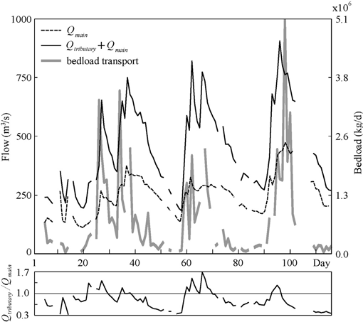

Fig. 5. Upper plot: daily total discharge ( black salid lin e) computed using the slope-area method , daily total bedload discharge (grey line ) obtained through field measurements and main river daily discharge, measur ed upstream of the confluence (dashed black line ). The abscissa spans the study period, from day 1 (16June 2013) to day 117 (3 0 Sep­ tember 2013 ). Bottom plot: discharge ratio (tribut ary over main river ) during the study period.

recession limbs, respectively. The maximum daily bedload transport ex­ ceeds 5000 t and is registered on a day during which the main river dis­ charge is dominant. Transport rates exceeded 2000 t/day on eight occasions that usually correspond to days when the tributary discharge is dominant. The mínimum transport rate attained during the campaign is as low as 24 t/day. So, the ratio of mínimum to maximum transport rates is 200. In contrast, maximum river discharge is only five times higher than mínimum river discharge in the same period . This high­ lights the nonlinear relation between bedload and discharge. For the en­ tire study period of 117 days, the total amount of bedload across the study section is -64,000 t.
Quantifying total bedload was the basic goal of the study, already met with this result, but accurate extrapolation of this figure, beyond simple empiricism and to longer time periods, is also of interest. It re­ quires a deeper knowledge of the local characteristics of sediment trans­ port. The following sections of this paper focus on the analysis of bedload, namely its spatial distribution across the river section and its distribution by size fractions.
Given that tributary flow is usually dominant during high discharge peaks, and most bedload transport occurs during those episodes because of the nonlinear relation between bedload and discharge, we anticípate that the tributary has a similar or even higher contribution to total bedload than the main river. The confluence is either approximately balanced or unbalanced in favour of the tributary in terms of bedload. A relevant exception is the maximum recorded bedload rate, registered on a day when the main river flow was dominant.

  - Transect morphology change

Water depth values obtained using the plumb lineare in good agree­ ment with bathymetric survey data. Two independent bathymetric sur­ veys of the river bed, made on 28 June and 17 July 2013, provide detailed data that are used to analyse the change ofthe study area mor­ phology. The survey dates correspond to day 23 and day 42 of the bedload sampling campaign ( Fig. 5 ). They encompass a period during which the first and second discharge peaks of the season occur. Flow rates decrease gradually after the first high-flow episode, but increase

Fig. 6. Upper plot: scatter plot of dail y water leve) at the three staff gauges against daily total discharge . Staff gauge s sg3, sgl, and sg2 are located in absc issas O, 1326, and 1425 m, respectively. Bottom plot: sketch ofthree longitudin al surface profiles at the con­ fluence, according to the staff gauges, for three particular discharges of 400 (a), 650 ( b ), and 900 m³/s (e); bed profiles are taken along the tributary and main river axis from Fig. 4 and exte nded upstream wit h a 0.2% s lope. The transect is located at abscissa 224 m.

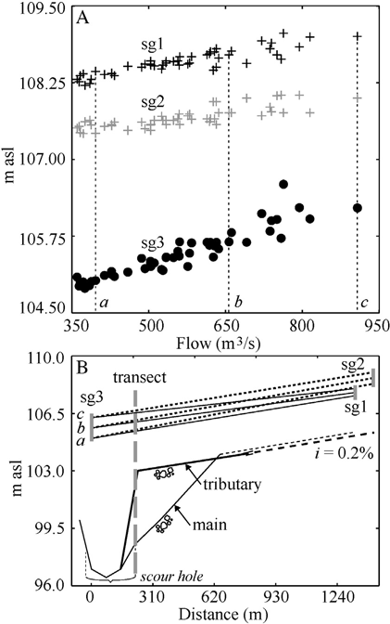
again shortly after and attaining 750 m³/s during the second, higher peak, which occurs on day 38 of the campaign.
The results of the two bathymetric surveys of the study transect are compared in Fig. 7A. Even though there are no majar changes, on day 42 the river bottom in the deep area (as defined previously) is -0.5 m lower than on day 23. Moreover, the free water surface is about 0.5 m higher at the time of the second survey, which is carried out under higher flow cond itio ns. The general scour of the river bottom in the deep area suggests that high flows entrain bed material in that region. An inverse fill can be expected during the recession ( Mart ín-Vid e and Capapé, submitted for publication ). Survey data also suggest that the scour hale at the confluence is subject to a transient general scour (and fill) that goes in accordance with the discharge and the free surface elevation ( Figs. 4 and 7A, the centre ofthe scour hale is at the toe ofthe stagnant, swirling area).
Survey data also show the change of the underwater bar profile in the shallow area. The 1-m drop that exists in the area at the time of the first bathymetric survey is noticeably bigger when the second sur­ vey is made, and it has migrated toward the deep area . lt resembles the lee-face of a large bedform occupying the shallow area. This move­ ment, which could result in the building up of the bed discordance be­ tween the two rivers, may be related to the bedload originated in the tributary and carried through the shallow area. However, the morpho­ logical balance at the confluence, during the period ranging at least from 2009 to 2013, dictates that the bed discordance cannot grow indef­ initely. Instead, the present drop, or perhaps bedform, is anticipated to eventually plunge into the deep area through the avalanche face, and presumably a new bedform could appear afterward and migrate across

the shallow area in the same manner. The long edge from the tip of the península to the point bar at the separation area represents the crest of the avalanche face.

Bedload distribution across the transect

Fig. 7 B and C displays mean bedload transport at the cross section transect, obtained for each station as the average of ali measurements taken at that station. In order to close the polygon, boundary conditions are set as follows: (i) no bedload transport occurs in the swirling area adjacent to the left river bank; and (ii) similarly, bedload is zero in the mean position of the right river bank in the bar.
Bedload transport mean values corresponding to each sediment size fraction were computed using the subset. The efficiency-corrected mean transport rate for each fraction (medium and coarse sand; and fine, medium, and coarse grave)) is plotted in volume per unit width (i.e., unit bedload transport m²/s, Fig. 7B). The presented values are thus the result of applying efficiency coefficients (e.g., 0.37 for coarse grave), see Section 5.1 ) to raw sediment quantities obtained through sieving of the dry samples. Material in the range of 64 to 76 mm (cob­ ble) is not included in Fig. 7 B and is excluded ofthe following analysis because of the high uncertainty associated to HS low efficiency for this fraction. Even though the graph provides accurate information on bedload sizes, the number of samples ( the subset only) limits the statis­ tical significance.
The results shown in the second graph ( Fig. 7C), on the contrary, were obtained through the analysis of the entire efficiency-corrected data set (1193 samples, among which 940 were not sieved). As men­ tioned in Section 6.1, the integration of the values across the entire sec­ tion yields a total bedload of 64,000 t for the duration of the survey campaign. Fig. 7C also shows the difference between raw measure­ ments and estimated, efficiency-corrected final quantities (including the fraction 64-76 mm in this case). This graph is more statistically
significant than Fig. 7B because it is based on the entire data set, but less accurate because the estímate of grain-size distributions for nonsieved samples brings a degree of uncertainty.
From Fig. 7 bedload transport is higher in the deep area than in the shallow area. Fig. 7B shows that bedload corresponding to the 45-m­ wide deep area (abscissas 15 to 60 m) accounts for 65.7% of the total volume. The remaining 34.3% corresponds to the 70-m-wide shallow area (abscissas 60 to 130 m). As efficiency decreases when particle size increases, the difference between raw and efficiency-corrected values is substantially larger in the deep area than in the shallow area ( Fig. 7C), making bedload estimates more uncertain in the former than in the latter. Excluding the recirculation area, where no transport was registered, the second lowest transport rates correspond to the transition zone between the shallow and deep areas (abscissas 55 to 70 m). In this sector, bedload is almost exclusively composed of sand ( Fig. 7B). This includes the leeward region ofthe assumed bedform mi­ grating along the shallow area. High and low bedload rates occur in the rest of the transect without a clear spatial pattern. The difference be­ tween Fig. 7A and B also illustrates that bedload transport is highly irregular.

Grain-size distributions

Table 1 presents the grain-size analysis results for the three near­ confluence alluvial samples ( Fig. 1 ). They confirm that the main river and the tributary are gravel-bed rivers with a low sand content. The main river, however, is noticeably coarser, more uniform, and less sandy than the tributary. Therefore, under the same hydraulic condi­ tions the main river is anticipated to transport less bed material than the tributary. The grain-size composition ofthe material in the conflu­ ence bears a closer resemblance to the tributary bed than to the main river bed. The composition of the sample collected in the península sep­ arating the two rivers ( Fig. 1 ) may correspond to the balance in the

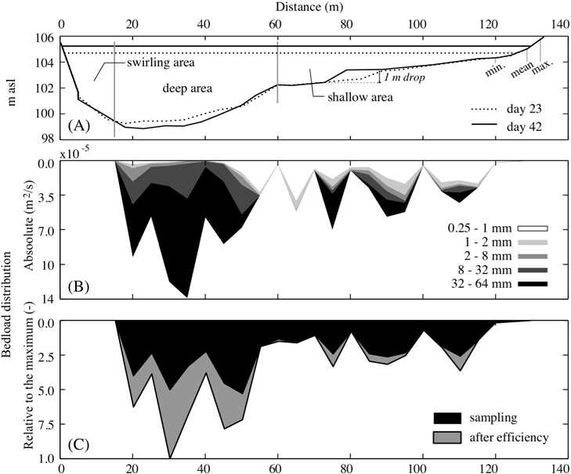

Fig. 7. (A) Study section bathymetryon day 23 (daily discharge equal to 302 m³/s, water leve!104.6 m asl) and day42 (daily discharge 590 m³/s, water leve!105.1 m asl). (B) Based on the subset of253 dried and sieved samp les : bedload distribution across the transect in m²/s divided into five grain-size fractions. (C) Based on the complete data set of 1193 samples: bedload distribution across the transect made dimensionless with the maximum value, befare and after the efficiency coefficients are applied (also called raw and estimated measurements).

bedload ofthe two rivers. Unlike the bedload samples, the coarsest frac­ tion (>64 mm) is considered.
The grain-size distribution of the subset is analysed in order to con­ firm and quantify two findings shown in Fig. 7B: in the shallow area, bedload contains material from ali size fractions, from sand to very coarse grave!. In contrast, sand is scarce in bedload samples of the deep area. The samples are grouped according to their provenance: shallow or deep area. Then, an average by volume grain-size distribu­ tion is obtained for each group after ali the samples have been corrected to correspond to the same sampling time (e.g., sediment volumes of each fraction of a 1-min sample have to be multiplied by a factor of 1O in order to be compared with sediment volumes of a 10-min sample). Table 1 shows the grain-size distribution for the two groups: deep area and shallow area.
Results show that deep area bedload and tributary bed materials have similar grain-size distributions, particularly concerning the
exception of low-T conditions in the shallow area. On the contrary, high shear stress values do not always translate into high bedload quantities.
The data of the field campaign have different resolutions: y and q5 are measured at multiple stations in the transect, while Sfis an average measured once per day. Therefore, it is advisable to consider the severa! q5 measurements in one day as different outcomes of the actual bedload on that day: one measure for the deep area and one measure for the shallow area. This is made by integration of q5 and dividing the result by the active bed width (i.e., the swirling area is not included). Also, the depths y at the cross section are replaced by a daily mean Rh. Besides being consistent with respect to data resolution, this averaging reduces the scatter.
lndeed, average T ranges from 23 to 32 N/ m² in the shallow area and
from 94 to 106 N/ m² in the deep area. In spite of their lower scatter, av­ erage shallow area q ranges from 0.65 to 59 • 1 o- 6 m²/s (i.e., two orders
5
5

gravel-to-sand ratio (3.4 and 3.8, respectively) anda (6.2 and 7.3).
ofmagnitude, mean value of9 · 1-0
⁵ m²/s), and average deep area q

However, mean (Dm) and median (D₅₀ ) grain sizes ofthe bedload sam­ ples are bracketed by the values corresponding to the tributary and the main (note the cut at 64 mm in the bedload data, not in the bed sam­ ples). In the shallow area, bedload is predominantly composed by sand. Table 1 shows that gravel, which accounts for approximately two-thirds of the material of both river beds, is also abundant in the deep area bedload. Table 2 combines the results from Fig. 7 and Table 1 in an effort to further refine the bedload grain-size distribution at the cross section transect.
Grain-size distribution for sand and grave! are described in terms of a probability density function in discrete versions ( Fig. 8 ). The total area under any possible function is equal to one; the partial area overa size range is equal to its share of the total grain-size distribution as a fraction of one.

s_ Bedload analysis

  - Preliminary remarks on bedload

An analysis ofbedload can be made through the study ofthe relation between unir bedload (qsl and shear stress T = p • g • y • SJ, where pis water density, g = 9.81 m/s² is the gravitation acceleration, y is local
water depth or hydraulic radius Rh, and Sfis the energy gradient. The en­ ergy gradients at the confluence SJare derived from the staff gauge read­ ings ( Fig. 6 ) as the average of main river and tributary gradients. For a better estimation of T, see the last section on perspectives. Fig. 9 shows the semilog scatter plots by size fraction of unit bedload against shear stress from the subset data. Correlation coefficients remain low, the scatter in unir bedload reaches three orders of magnitude, and data points form two independent groups. This is because of the shape of the study section, characterized by a deep and a shallow area, so points are grouped in the abscissa according to the depth. The plots sug­ gest that there is no clear monotonically increasing relation between q5 and T that could be used as a bedload predictor, with the possible

Table 1
Summary of the grain-size distributions of near-confluence alluvial material ( Fig. 1 ) and averaged HS bedload samples: sand, grave!, and coarser material fractions (%); geometric mean grain size Dm (mm); median grain size D₅₀ ( mm ); and standard deviation a
(Ds4/ D15).

Sample Sand Grave! > 64 mm Dm Dso a
ranges from 1.3 to 360 • 10- ⁵ m²/s (i.e., more than two orders ofmag­ nitude, mean value of 43 • 1 o- 6 m²/s). Mean values of deep and shallow
areas q5 result in a total bedload transport of - 70,000 t in 120 days.
Bed material can move as bedload oras suspended load. Shear veloc­ ities v* (a surrogate ofT) should be compared with fall velocities ( v5) for different grain sizes (e.g., the V₅ :::::: 0.16 m/s for 2 mm size). The resulting average v* is 0.16 m/s in the shallow area and 0.32 m/s in the deep area. In the cases when v* > V₅, a portian ofthe total bed material load is bound to travel in suspension. Therefore, grave! particles (V₅ > 0.16 m/s) are antic­ ipated to move essentially as bedload in the shallow area. In the deep area, the same can be said of grave! particles >8 mm (V₅ :::::: 0.32 m/s, very fine and fine grave! following Vanoni, 1975 ).

  - Grain size

Two questions rise: does the grain-size distribution of sand or grave! carried as bedload, through any of the two areas deep or shallow, repli­ care the grain-size distribution of either main river or tributary? In addi­ tion, is the size distribution of sand connected to the parent sand sampled far upstream of the confluence in the tributary?
Fig. 8A shows that the sand fractions of the bedload in shallow and deep areas are very similar. However, this sand bedload does not have the same grain-size distribution as the sand fraction of either the tribu­ tary or the main river beds (very similar to each other as well). Further­ more, it is not a combination of sand from the two sources ( main river and tributary). On the contrary, sand bedload includes a medium sand fraction, predominant in the parent sand but scarce in the alluvial mate­ rial ofthe two near-confluence river beds. Given that HS sampling effi­ ciency is equal to 1 for particles in the range of0.25 to 2 mm, the results shown in Fig. 8 A are direct measurements, not including efficiency­ corrected data uncertainty.
Medium sand is abundant in the bedload but not in the near­ confluence alluvial material where coarse sand is predominant. This suggests high mobility ofthe parent sand, which was sampled at segre­ gated deposits of the tributary far upstream of the confluence. lt can be said that parent sand does not settle at the confluence but it moves in­ stead. Sand transport must be partially or mostly suspended load, as V₅ < 0.08 m/s in the range of0.25 to O.SO mm size (medium sand), and thus below the average v* of shallow and deep areas.

Table2
Bedload grain-size distribution at the cross section transect ( note: see Fig. 8 and discussion for the amounts by size fraction and the amount of parent sand).

(<2 mm ) (2-64mm) ( mm ) ( mm )
Area | 2-4 | 4-8 | 8-32 | 32-64 | Total | Parent | Rest | Total Total
 | mm | mm | mm | mm | grave! | sand | of | sand
sand
Main river (1) | 12% | 6 2% | 26 % | 23.6 | 40.7 | 3.4
Tributary (2) | 20% | 68 % | 12 % | 13.0 | 21.9 | 6.2
Confluence (3 ) | 23% | 67 % | 10 % | 11.1 | 19.0 | 7.1
Deep area | 21% | 79 % |  | 14.0 | 31.9 | 7.3
Shallow area | 73% | 27% |  | 1.6 | 0.9 | 7.3

- Not in cluded .
Shallow 3.7% 1.5 % 2.1% 2.0% 9.3 % 5.0 % 20.0 % 25.0 % 34.3%
Deep 7.8% 2.7% 13.4 % 28.0% 51.9 % 2.8% 11.0 % 13.8 % 65.7%
Total 11.5% 4. 2% 15.5 % 30.0 % 61.2% 7.8% 31.0% 38.8% 100%

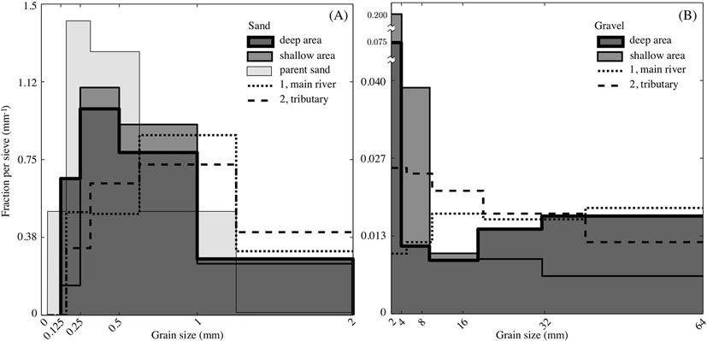

Fig. 8. Grain-size distribution in terms of a probability density function for (A) sand and (B) grave!. Size density in ordinates in mm- 1 and size in abscissa in mm. Results for the main river and tributary beds and for shallow area and deep area bedloads (discrete data). Parent sand is included in (A ). The partial area overa size range is equal to the share of the total grain-size distribution as a fraction of one. Table 2 has the actual bedload quantit ies . The graphs are not freque ncy histograms. Note that ve1y fine and fine sand particles (<0.25 mm, the HS mesh size) must have been attached to larger particles in order to appear in the bedload size distributions.

Although suspended load remains out of the scope of the present case study, if near the bed suspended sand is collected by HS and an efficiency coefficient >1 should be applied (efficiency coefficient is 1 far sand 0.25-
0.5 mm, neglecting the suspended transport). As a consequence, grain­ size distributions far bedload, main river and tributary beds would be more alike but more divergent ofthe parent sand ( Fig. 8A).
Unlike sand transport, Fig. 8 B shows that grave! material transported through the deep area is coarser than that transported through the shal­ low area. In addition, grave! in the bedload does not have the same grain-size composition than the main river ar the tributary river beds. lt shows a much higher percentage of very fine and fine grave! (2-8 mm) than the near-confluence river beds and also a lower per­ centage of medium grave! (8-16 mm) than those. lf this 2-8 mm frac­ tion is excluded from the graph, the grain-size distribution of the
shallow area bedload would approach the distribution of the tributary material. To a lesser extent, the grain-size distribution of the deep area bedload would be similar to the one of the main river.
Part of the 2-8 mm grave! present in the bedload samples must have originated far upstream from the confluence, as it is not abundant in the near-confluence aliuvial beds of either the main river ar the tributary. As HS sampling efficiencies are not equal to 1 throughout the whole grave! range, the results in Fig. 8 B are estimares and not certain. Actually, if grave! in the bedload had the same grain-size distribution of the local bed material, Fig. 8 B would concede the precise HS efficiencies (i.e., the efficiency coefficients that match bedload and river bed grain-size distributions). This is an unwise statement in view ofthe complexities of bedload transport in grave! bed rivers and would lead to efficiencies
» 1 far the very fine gravel.

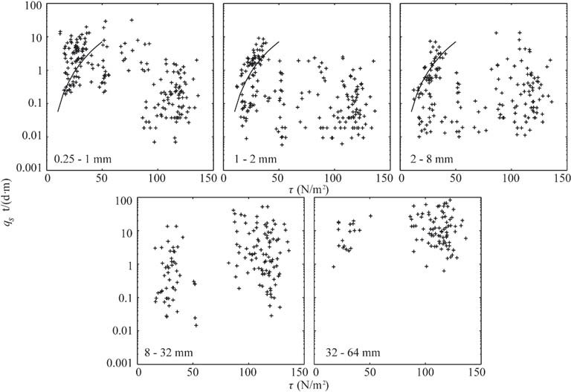

Fig. 9. Semilog scatter plots of unit bedload discharge against shear stress, by five sediment size fractions. A monotonic fitting of the type q, = k · i', where k is a constant, is tentatively drawn in the first three plots.

Instead, we assume that differences in Fig. 8 B point to ( i) the division ofbed material load between bedload and suspended load, and (ii) the controls of the grave! transport. Grave! bedload through the shallow area (low shear stress, no suspension) contains less very coarse and coarse grave! and more very fine and fine grave! than through the deep area. This suggests that the available shear stress controls the shal­ low area grave! bedload. The following paragraphs discuss points
(i) and (ii) above. Later in the discussion, sorting and partía! transport are introduced.

  - Overview of bedload predictors

This section analyses different formulas that aim to provide an estí­ mate ofbedload transport (i.e., bedload predictors), sorted by grain-size fractions, by comparing their results with field data. The goal is two­ fold: (i) first and foremost, to better understand which factors control bedload; and (ii) second to evaluare the performance ofthe different predictors and the ensuing effects on bedload extrapolation to periods for which field data do not exist. Point (i) is of uttermost importance in that it introduces the difference between below-capacity conditions ( i.e., the river does not supply enough bed material) and at-capacity conditions ( i.e., the river supplies enough bed material). At present, bedload predictors provide an estimate of real bedload only in that sec­ ond case. In the first case, real bedload is bound to be lower than any prediction. A bedload controlled by supply (availability) or controlled by capacity are altemative names for these two conditions.
The bedload predictors analysed in the following subsections are those presented by Wilcock (following Wilcock and Kenworthy, 2002; Wilcock and Crowe, 2003), by Parker (following Parker, 1990 ), and by Meyer-Peter and Müller (MPM, according to Wong and Parker, 2006 ). The second one is a bedload formula, while the remaining two are bed material load formulas. The first two were derived with a surface grain size as input. Field data is worked out, as it is customarily done, to get
the Shields parameter 0 = T / (p • g • R • D) = y • s1 / (R • D), where T is the shear stress, R = ( Ps / p) - 1 is the submerged specific gravity of sediment, Ps = 2600 kg/ m³ is sediment density, and D is grain size
(in m); the Einstein mobility parameter <P = q / J (g • R • D³ ) , where q5
5
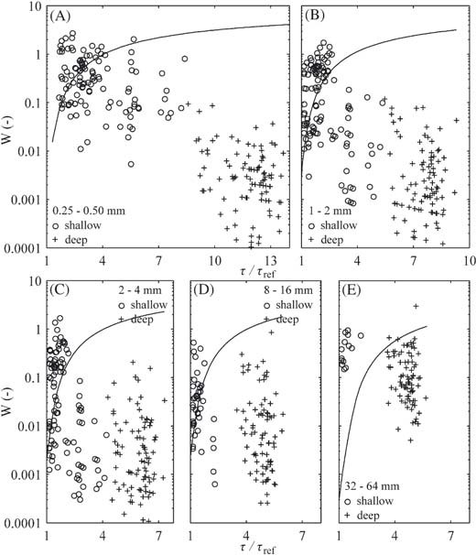
is the unit bedload and g = 9.81 m/s²; and finally, the quotient W =
2
from at-capacity to below-capacity conditions, or (ii), at-capacity condi­ tions persist, but only one-tenth of sand (in terms of W) remains as bedload (the remaining nine-tenths are suspended). The second possi­ bility is more sensible because the tributary is the majar supplier of sand to the shallow area. Moving to the deep area, where sediment transport capacity increases, it is not clear whether any of the previous two possi­ bilities applies (a shift to below-capacity conditions or an escalation of sand entrainment into suspension or both), and this medium sand bedload appears uncorrelated with T / Tref•
The same reasoning is extended to very coarse sand and very fine
grave! ( Fig. 10 B and C) where measured bedload data lie closer to the predictor in the shallow area than in the deep area. Then , on one hand, shallow area transport is at-capacity; on the other hand, deep area transport is either below-capacity conditions or the entrainment into suspension explains the lack of agreement or both are concurrent causes.
Transport mode for medium grave! 8-16 mm ( Fig. 10 D) is primarily bedload. Therefore, below-capacity conditions should explain solely the lack of agreement between measured data and predicted. For the very coarse 32-64 mm fraction, apparently the predictor underestimates the transport capacity in the shallow area, while the transport may overall be still below-capacity conditions in the deep area.

5.5. Parker bed/oad predictor

Parker's method focuses on the grave! fraction of the bed material load, which is assumed to move as bedload. Sand fraction is excluded from the analysis, but the hiding/exposure effect of different sizes in
the mixture is taken into account. In this case, 0rer = 0.0386, which
means critica! conditions (abscissa equal to one is the threshold of movement). Any inaccuracy in the setting of Tref, as in Wilcock's method

c/J / 0³ / • The sample at the confluence is used for D. Depthy and energy
gradient s1 do not vary much from day to day in response to the chang­ ing discharge Q In particular, with Qincreasingy increases, s1 decreases,
and the producty · 51slightly decreases ( Fig. 6 ) (in spite ofthe five-fold range of discharges throughout the campaign). On the contrary, the var­ iation of y • s1 is high from point to point of the transect. In this context,
any altemative to the average of s1 is negligible . The results of the first
two predictors are presented in semilog plots of W vs. T / T ref, where
T ref is a reference or critica! bed shear stress.

5.4. Wi/cock bedload predictor

This method is deemed to best address the interaction between sand and grave! in the bed material load of gravel-bed rivers. The required Tr ef
is the shear stress that causes a very small bedload transport W = 0.002,
different for each size fraction . In this case few data had such a small transport. For this reason, the values in the abscissa T / Tref cannot be very accurate. The result s are shown in Fig. 10 for five size fractions.
For sand 0.25- 0.50 mm ( Fig. 10 A), measured shallow area transport is clase to the predictor (at least for low T / Trer values), whereas mea­ sured deep area transport is two to three orders of magnitude lower than the predictor. In spite of the scatter, for low shear stress the higher the shear stress the higher the bedload is. Thus, shallow area sand trans­ port is at-capacity. The river carries as much medium sand as it can as bedload, according to Wilcock's method, under the available shear stress. In the transition between the shallow and deep areas, likely to be on the leeward of a bedform ( Fig. 7A), either (i) the control shifts

Fig. 10. Semilog plots of measured bedload trans port in deep and shallow areas and the Wilcock predictor ( fu ll line ) for five grain- s ize fraction s: (A) medium sand (0.25-
0.50 mm ). ( B) ve ry coarse sand (1- 2 mm ). (C) ve ry fin e grave! (2- 4 mm ). (D) medium grave! (8- 16 mm ), and (E) very coarse grave! (32- 64 mm ). The same scale is applie d to ali graphs.

above, is avoided. The results are shown in Fig. 11 for three size fractions.
Overall, the results follow the same trend as Wilcock. Shallow area data plot (more consistently than in Wilcock) below but close to the predictor. Deep area data plot below the predictor with no monotonical trend so, as stated above, bedload transport may be below-capacity con­ ditions. Moreover, the coarser the fractions, the closer the data plot to the predictor and the larger the bedload amounts are. The same feature appears in Wilcock ( Fig. 1O) and in the gravel-size distribution ( Fig. 8B), where for example the 32-64 mm fraction takes -54% of the gravel bedload of the deep area, that is to say sorne 28% of the total bedload ev­ erywhere (Table 2).

5.6. Meyer-Peter and Müller bedload predictor

The Meyer-Peter and Müller formula is included because ofits wide­ spread use in practical sediment transport computations for gravel-bed rivers up to 30 mm in grain size. The MPM cannot rival the previous two methods for their description of bedload, although it is also applied by fractions, including hiding /expos ure factors. The total bedload is obtain­ ed by summing up ali fractional bedloads. The MPM results should be compared with the integrated data, at most dividing between shallow and deep areas.
The results from the classic MPM and the measured data differ by more than four orders ofmagnitude (the predicted q5 are much larger), irrespective of the area (deep or shallow) considered. The difference is two to three orders of magnitude if form drag reduction is applied. Thus, the indiscriminate use of the MPM formula would yield an im­ plausible total bedload transport compared to the total reported value of 64,000 t.

- Discussion

Bedload predictors, capadty conditions and grain-size distribution

The three methods presented in the previous section predict bedload values well above measured quantities, at least in the deep area. The results obtained using MPM, which stand out among the three, serve as a warning about the inaccuracies to be expected when estimating bedload with no real data. The MPM is a bed material load formula based on flume experiments. On the contrary, this is a field re­ search and only bedload is the target, two important differences. We ad­ here to Wilcock (2001) in that substantial discrepancy between field data and predictors make advisable a mínimum of oriented field surveys of bed material load prior to using any formula in a real case.
Transport rates by fractions in a gravel-bed river, such as those pre­ sented in Fig. 1 O, are subjected to the complex phenomena of sorting of
particles at the bed surface (coarser than the bulk material) and partial transport ofthe coarse fractions (only a portian ofthe grains in the frac­ tion moves ). Partial transport explains why transport rates are smaller for coarse sizes than for less coarse sizes with respect to their presence at the surface. Consequently, the bed is armoured because the coarse fractions become over-represented at the surface. The complete mobili­ zation of a size fraction occurs at roughly twice the necessary shear stress for incipient motion of that fraction, i.e., for T / T, er 2 (Wilcock and McArdell, 1993). For this reason, partial transport is notan explana­ tion for the discrepancies between data and predictors in the deep area where T / T,er » 2 (discrepancies up to two orders of magnitud e), al­ though it may be different in the shallow area. The inaccuracy fitting T,er with only a few measures of small transport obscures these conclu­ sions. However, lower values for Tref (and therefore higher T / Trer) are obtained from the suggested formulas from Wilcock and Crowe (2003) . Thus, sediment transport under below-capacity conditions rather than at-capacity conditions appears to be the main cause of the inaccu­ racy ofbedload predictors. Although real bedload is overpredicted when supply is lower than capacity, this may concur with sediment entrain­ ment into suspension, which applies to sand everywhere and very fine and fine grave! (in short fine grave!) in the deep area. The control by supply is left alone in the remaining domain, i.e., medium and coarser grave! everywhere and fine gravel in the shallow area. The agreement or disagreement with predictors is shared by the two causes or only by the supply ofbed material. This remains the framework of the discus­ sion, once partial transport is notan explanation for the large discrepan­ cies in the deep area. The last factor, related to the planform, will be
introduced in the next section.
Deep area sediment transport appears to be at below-capacity con­ ditions for medium and coarser grave! fractions ( Fig s. 10 and 11), as the high transport capacity in this area largely exceeds the supp ly. In contrast, shallow area sediment transport appears at-capacity condi­ tions for ali grave! sizes. As far as sand is concerned, the entrainment into suspension may be significant in every case when the predictor re­ sults are larger than the measured data. Otherwise, the predictor sup­ ports that bedload is at-capacity as much as the data confirms the predictor. In the deep area, as the fraction is coarser and scatter data gets closer to the predictor, the role of suspension becomes less impor­ tant and transport at below-capacity conditions progresses as the only plausible argument.
The size distribution of shallow area grave! bedload ( Fig. 8B) reveals how transport capacity works where bedload should be the sole mode of transport. The amount of two gravels, 40% of 2-4 mm and 21% of 32-64 mm, is an outcome of a particular q5 - T relationship expressing a trend of increasing load under increasing shear stress in the shallow area, i.e., a capacity function ( Fig. 11 ). In contrast, deep area gravel bedload has less very fine (15% of 2-4 mm) and more very coarse

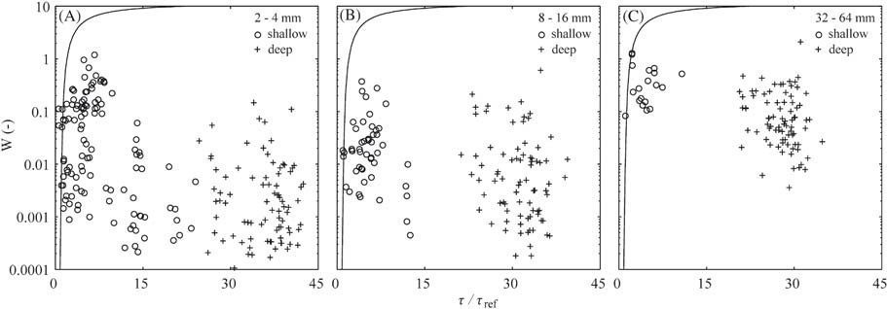

Fig. 11. Semilog plots ofmeasured bedload transport in deep and shallow areas and the Parker predictor ( fu ll line ) far three gravel size fractions: ( A) very fine gravel (2- 4 mm ), ( B) medium grave! (8-16 mm ), and (C) very coarse grave! (3 2- 64 mm).

(54 % of 32-64 mm) grave!, and there is nota clear trend in the relation­ ship between q5 and T. The relatively small 15% of very fine grave! caught by the HS should be a consequence of an entrainment into sus­ pension (this cause only applies to the finest fractions). The 54% of very coarse grave!, relative to the main river grain-size distribution, is opposite from the idea of partía! transport.
The sand bedload grain-size distributions in the shallow area and in the deep area are very similar ( Fig. 8 A), in spite of (i) the different con­ ditions of sediment transport (i.e., below-capacity in the deep area and at-capacity in the shallow area) and (ii) the sand in the deep area being more prone to be entrained into suspension than in the shallow area ( e.g., for sand 0.25-0.50 mm v* / V₅ is 4 in the deep area but 2 in the shallow area). lfthe parent sand is considered, bed samples ofthe main river and the tributary require 20% of parent sand in order to ap­ proximately match both the deep area and shallow area sand bedload grain-size distributions ( Fig. 8 A).
The amount of bedload through shallow and deep areas ( Fig. 9 ) is similar for fine grave! and coarse sand, is surpassed in the shallow area for medium sand, and is surpassed in the deep area for medium and coarser grave! (Table 2). Nevertheless, despite the fact that the bedload in the deep area is larger (65.7 %) than in the shallow area (34.3 %), it is surprising to realize that it could have been much larger (orders of magnitud e) if the rivers had supplied more material. The main river in particular may be responsible for this shortage of material. This idea and the influence of the planform are explored next.

Balance between main river and tributary

Given the transect location ( Fig. 4 ), it is obvious that the bedloads through the shallow (34.3 %) and deep (65.7 %) areas (Table 2) are not the same as the loads brought by the tributary and the main river, re­ spectively. The shallow area HS measurements do not fully record the tributary bedload. On the contrary , a long edge between the shallow and the deep discordant areas ( the crest of the avalanche face) expands
-200 m upstream ofthe transect. Thus, the confluence region is also di­ vided into two, a sha llower area to the right anda deeper area to the left. A part ofthe tributary load moves into the deeper area across the imag­ inary border dividing these two areas.
lf the confluence is unbalanced in favour of the tributary in terms of bedload, could the deep area bedload transport be solely brought by the tributary? Following the results from previous sections, this is suggested by grain-size distributions of the deep area bedload and the tributary are alike, shallow and deep areas share a similar sand (in terms of grain-size distribution), and the source of parent sand is mainly the trib­ utary. Next, the method of proof by contradiction is used to show that the tributary is not the only source of bed material load at the cross sec­ tion transect.
Consider two types of bedload at the transect. On one hand, the di­
rect type is tributary bedload crossing the transect through the shallow area; on the other hand, the indirect type is tributary bedload crossing the transect through the deep area after moving into the deeper area of the confluence as explained above ( think of a transfer from the trib­ utary to the nonsupplying main river). The direct type oftransport is es­ sentially at-capacity, but the indirect type alone (acting as supply) is not enough to meet the deep area transport capacity.
In parallel, bedload is divided in two by means of the mode of trans­ port. Grave! from the tributary moves mostly as bedload, but the sand moves as either bedload or suspended load; and the suspension be­ comes dominant near the edge. As load enters the deep area, fine grave! and certainly sand probably are bound to be entrained into suspension. Although it is not measured , the suspended sand transport must be higher than the suspended fine grave! transport.
Alternatively, sorting of bedload may occur along the edge. This is supported by a similar situation in bend flow ( Parker and Andrews, 1985; Clayton and Pitlick, 2007). In that case, coarse material moves to­ ward the outside of the bend, whereas fine material moves toward the
inside. The reason is the balance between two forces acting on the grains: the gravity force and the drag force biased by the helical flow. This balance is size-dependent. The helical flow caused by the discharge of the tributary into the main river (disclosed by the reddish water and floating debris) and the bend flow are counterclockwise. The former is superimposed to the latter, similarly to what happens to the flow de­ flection and the bend scour (see Section 2). Thus, the actual planform at the confluence involves two different mechanisms, one is the junc­ tion ofthe streams ( t he discharge ofthe tributary into the main rive r), occurring basically upstream of the transect, and the other is the sudden turn to the right (bend ), occurring basically downstream of the transect. Sorne overla pping of these effects exists.
The fraction of sand out of the total amount in the shallow and the deep areas is 25.0% and 13.8%, respectively (Table 2). The escalation of the nonmeasured suspended mode of transport when load enters the deeper area may explain this unbalance. Also, the sorting in the separa­ tion area may explain a higher quantity of sand passing through the shallow area, because it nourishes the dynamics of the bar ( Fig. 3 ) and, consistently, it may explain a higher quantity of grave! moving into the deeper area.
A split of grave! 2-4 and 4-8 mm in a ratio 2:1 ofthe indirect over the direct type of bedload agrees well with the actual data (Table 2), i.e., two-thirds of the total bedload are of the indirect type and one­ third is ofthe direct type, e.g.,for 2-4 mm, 11.5% is the total, 7.8% the in­ direct type or deep area, and 3.7% the direct type or shallow area. How­ ever, medium and coarser grave! bedload in the deep area <loes not justify a ratio 2:1 of only tributary load. In fact, measured data and the 2:1 split differ by a total amount of ± 8.0% for 32-64 mm and ± 3.1% for 8-32 mm. For 32-64 mm it is a mere 2% instead of 10 % in the shallow area and, conversely, 28% instead of 20% in the deep area, out of a 30% total fraction. Then, either a higher split ratio holds for medium and coarser grave!, supported by the sorting effect that pulls coarse particles toward the outside, or the tributary is not the only source of bed mate­ rial load. The first idea is intuitively supported by Fig. 7B, resembling a segregation between coarse and fine particles. However, the tributary is very unlikely to be the only source of very coarse grave! 32-64 mm (it amounts to 30%) as the shallow area carries only 2% at-capacity con­ ditions (it cannot be larger).
The tributary bed has twice as much grave! 2-4 and 4-8 mm as the main river bed (although bedload exceeds these quantities) ( Fig. 8B). This supports the idea that the tributary brings most gravels 2-4 and 4-8 mm. Fu rthermore , bedloads are proportional over these two frac­ tions in Fig. 8 B, i.e., the deep area bedload distribution is matched by di­ viding the shallow area bedload by a factor of -3 (a factor of -0.5 considering the actual amounts represented in Fig. 8 B). This supports the idea of a split indir ect/dire ct ata constant ratio for very fine and fine grave! (2-8 mm) and so it <loes not contradict the tributary as the only supply.
On the contrary, in further support of the main river supply, recall that the deep area bed at the confluence was scoured 0.5 m in the main river in the second largest discharge of374 m³/s (day 38, total dis­ charge 750 m³/s; Fig. 5 ). The main river's largest discharge of 473 m³/s (day 99, total discharge 762 m³/s anda low tributary/main discharge ratio 0.61) was concurrent with the maximum measured bedload trans­ port ( >5000 t). This is the relevant exception, mentioned above, be­ cause the tributary was not dominant. Day 99 carne two days after the largest flow at the confluence, 906 m³/s, but is less important in terms ofbedload.
Consequently, although the tributary provides higher bedloads on average, the main river apparently has a more nonlinear behaviour, being capable of supplying large amounts of coarse bedload for high dis­ charges. This behaviour is similar to a mobile armour in the main river bed because it explains a very coarse material transport during high flows compatible with a shortage of supply in other days of the high flow season. This armour is bound to become static in low flow and, eventually, there is a threshold for any bedload transport.

].P. Martín-Vide et al. / Geomorphology 250 (2015) 15-28 27

Near-confluence bedload moving through the deeper area could also overcome the bed discordance and reach the bar ( think of a transfer from the main river to the shallow area). The outward near-surface flow (revealed by the floating debris and the reddish water) needs to be matched by an inward near-bed flow, which precisely pushes bed material toward the shallower area as part of the helical flow. However, this may be more intense where the scour hole is the deepest and thus downstream of the transect.
Boyer et al. (2006) found that the highest transport rates occur near the edges of the shear !ayer between the two streams. Accordingly, the swirling area with no transport ( Fig. 7 ) is to the left of the shear !ayer left edge. Changes in the position ofthe shear !ayer induced by discharge ratio variations, particularly when the main river flow is dominant and the shear !ayer is displaced to the right, will change the bedload dis­ tribution. Fig. 7 is only an average of ali these situations. Best and Rhoads (2008) highlight that the scour hole at the confluence hinders the enter­ ing of bedload, which moves along the flanks of the hole. In that case, Fig. 7 shows the energetic role of the tributary pushing the hole to the left and supplying most of the bedload.

Conclusions

During the 3-month field campaign, bedload transport varied 200- fold and discharge varied five-fold. Overall, total bedload volume was 64,000 t and contained 39% sand and 61% grave!. At the transect, the 45-m-long deep area accounted for 66% of the total bedload; the 70- m-long shallow area accounted for the remaining 34%. The former is mostly grave! while the latter is mostly sand. The measurement of bedload through the deep area is more uncertain because the sampler efficiency diminishes for coarser material.
The naturally regulated main river is dominant on the particular day when the maximum transport of 5000 t/day was registered. However, quantities exceeding 2000 t/day are typically obtained when the unreg­ ulated tributary is dominant. The confluence is probably unbalanced in favour ofthe tributary in average bedload volumes. Moreover, it seems that a tributary flood drove a recent shift of the confluence morphology. A bed discordance probably swept by a bedform, a transient scour hole, and signs of sorne helical flow are other field observations. The dis­ charge of the tributary into the main river is superimposed to bend flow caused by a sharp tum of the stream.
Tributary bed grain size is finer than the main river. Grain-size distri­ butions of the deep area bedload and the tributary are similar. Sand bedload size distributions in the shallow area and in the deep area are very much alike. However, grave! bedload size distribution is coarser in the deep area than in the shallow area. Parent sand sampled in the tributary, farther upstream from the confluence, is needed for matching grain-size distributions of near-confluence river beds with the sand bedload. Also very fine and fine grave! come mainly from the tributary. lt ali suggests that the tributary is the main source ofbedload material at the confluence, and ultimately the contribution of the main river may be negligible, except for very high flows.
Bedload predictors by Wilcock (for sand and grave!) and by Parker (for grave)) agree reasonably well with the measured bedload in the shallow area. In contrast, the predictors yield quantities orders of mag­ nitude higher than measured data in the deep area, therefore bedload could have been much larger ifthe rivers had supplied more material. The main river may be mainly responsible for this shortage of material. The predictor discrepancies serve as a warning about the errors to be expected when estimating bedload with no real data.
Accounting for the entrainment into suspension, bedload transport is at-capacity in the shallow area but below-capacity in the deep area. This is deemed the main reason for the large discrepancies. The role of the partía! transport in the deep area seems limite d. Suspended trans­ port of sand must be significant in deep and in shallow areas. In the deep area, suspended transport of very fine and fine grave! may also be significant. The bedload transport in the deep area is certainly

nourished by the tributary. The helical flow sorting effect of superimposing bend and confluence flow pattems explains the nourish­ ment of the deep area in coarse sizes and the shallow area in fine sizes, including the separation bar.
At the confluence, the main river is a source of bedload material but seldom active, crossing the deeper area. lts great nonlinearity is similar to the behaviour of a mobile armour. So, bedload transport is predomi­ nantly below-capacity in the main river. Tributary bedload transport is, in tum, at-capacity and it is the major source ofbed material. The pres­ ent morphology at the confluence is presumably shaped by this mechanism.

Perspectives

This paper is devoted to an overall description of bedload transport in the confluen ce. This approach has required the time-averaging of the main variables, i.e., the bedload rates across the transect ( Fig. 7) and the grain-size distributions of bedload ( Fig. 8 and Table 2). The flow and shear stress are also averaged, in time and space. Only for the assessment of predictors the data are not time-averaged. Therefore, the results are meaningful as average trends of the bedload dynamics. Next step is the separare analysis of the main events. The bedload amounts across the transect (shallow and deep areas) and their size dis­ tributions will be compared for different events at the confluence driven by a high flow in the main river, in the tributary, or both. A numerical model of the confluence will provide the velocity field and improve the local bed shear stress estimates.

Acknowledgements

We thank ERH Consult, Lluis Viver, Carlos Hermosilla, and Luis Espinoza and his team in Ch ile. We thank the referees and Richard A. Marston, Editor of Geomorphology, for their thoughtful and construc­ tive reviews of this manuscript.

References
Ashmore, P., Parker, G., 1983. Conlluence scour incoarse braided streams. Water Resour.
Res. 19 (2 ), 392-402. http: //dx.doi.org/10.1029/WR019i002p00392.
Batalla, R.. Martín-Vide, j.P.. 2001. Thresholds of particle entrainment in a poorly sorted sandy gravel-bed river. Catena 44 (21), 223-243. http: //dx.doi.org/10.1016/S0341- 8162(00)00157-0.
Best,j.L.. 1987 . Flow dynamics at river channel conlluences : implications for sediment transport and bed morphology. In: Eth ridge, F.G., Flores, R.M., Harvey, M.O. ( Eds.), Re­ cent Developments in Fluvial Sedimentology. SEPM Special Publication 39, pp. 27-35. http: //dx.doi.org/10.2110/pec.87.39.0027.
Best, j.L., 1988. Sediment transport and bed morphology at river channel conlluences.
Geomorphology 35 (3), 481-498. http: //dx.doi.org/10.1111/j.1365-3091.1988. tb00999.x.
Best, J.L., Rhoads, B.L., 2008. Sediment transport, bed morphology and the sedimentology
ofriver channel conlluences. In: Rice, S.P., Roy, A.G., Rhoads, B.L. (Eds.), River Conllu­ ences, Tributaries and the Fluvial Network. John Wiley and Sons, Ltd, Chichester, UK http: //dx.doi.org/10.1002/9780470760383.cM .
Biron, P., Best, J.L., Roy, A.G., 1996. Effects of bed discordance on llow dynamics at open channel conlluences.j. Hydraul. Eng. 122 (12 ), 676-682. ht tp://dx.doi.org/10.1061/ (ASCE)0733-9429(1996)122:12(676) .
Boyer, C.. Roy, A.C., Best, J.L., 2006. Dynamics of a river channel conlluence with discor­ dant beds: llow turbulence, bed load sediment transport and bed morphology. J. Geophys. Res. 111 ( F04007). http: //dx.doi.org/10.1029/2005jf000458.
Bunte, K., Abt, S.R., 2009. Transport relationships between bedload traps and a 3-inch Helley-Smith sampler in coarse gravel-bed streams and development of adjustment functions. Completion Report 218. Colorado Water l nst it ute, Colorado State University, Fort Collins, CO.
Clayton, JA.. Pit lick, J., 2007. Spatial and temporal variations in bed load transport inten­ sity in a grave! bed river bend. Water Re sour. Re s. 43 (2 ), W02426. http :// dx.doi.org/ 10.1029/2006WR005253.
De Serres, B., Roy, A.G., Biron, P.M., Best, j.L., 1999 . Three-dimensional structure ofllow at a conlluence of river channels with discordant beds. Geomorphology 26 (4 ), 313- 335. http: //dx.doi.org/10.1016/S0169-555X(98)0 0064-6.
Emmett, W.W.,1980. A field calibration of the sediment trapping characteristics of the Helley-Smith bedload sampler. U.S. Geological Survey Professional Paper 1139.
Helley, E.J., Sm it h, W., 1971. Development and calibration of a pressure-difference bedload sampler. U.S. Geological Survey, Open-File Report 73-108.
Lane, S.N., Bradbrook, K.F., Richards, K.S., Biron, P.M., Roy, A.G., 2000. Secondary circula­ tion cells in river channel conlluences: measurement artefacts or coherent llow

structures? Hydrol. Process. 14 (11-12 ). 2047-2071. http: //dx.doi.org/10.1002/1099- 1085(2 0000815/30)14:11/12<2047::AID-HYP54 >3.0.C0;2-4.
Leclair, S.F., Roy, A.G., 1997. Variabilité de la morphologie et des structures sédimentaires du lit d'un confluent de cours d'eau discordant en période d'étiage . Géog. Phys. Quatern. 51 (2), 125-139. http: //dx.doi.org/10.7202/033114ar.
Martín-Vide,J.P., Capapé, S., 2015. Transient scour and fill: new evidence and research on its causes.]. Geophys. Re s. Earth Surf. (submitted far publication).
Parker, G., 1990. Surface-based bedload transport relation far grave! rivers.J. Hydraul. Res.
28 (4), 417-436. http: //dx.doi.org/10.1080/00221689009499058.
Parker, G., Andrews, E., 1985. Sorting of bed load sediment by flow in meander bends. Water Resour. Res. 21 (9), 1361-1373. http://dx.doi.org/10.1029/WR0 21i009p01361. Parsons, D.R., Best, J.L, Lane, 5.N., Orfeo, O., Hardy, R.J., Kostaschuk, R.A., 2007. Form roughness and the absence of secondary flow in a large confluence-diffiuence, Rio Paraná, Argentina. Earth Surf. Process. Landf. 32 (1 ), 155-162. http: //dx.doi.org/1O.
10 02/esp.1457.
Parsons, D.R., Best, J.L, Lane, S.N., Kostaschuk, R.A., Hardy, R.J., Orfeo, O., Amsler, M.L, Szupiany, R.N., 2008. Large river channel confluences. In: Rice, S.P., Roy, A.G., Rhoads, B.L ( Eds.), River Confluences, Tributaries and the Fluvial Network. John Wiley and Sons, Ltd, Chichester, UK. http: //dx.doi.org/10.1002/9780470760383.ch5. Qing-Yuan, Y., Xian-Ye, W., Wei-Zhen, L, Xie-Kang, W., 2009. Experimental study on characteristics of separation zone in confluence zones in rivers. J. Hydrol. Eng. 14
(2), 166-171. http: //dx.doi.org/10.1061/( ASCE)l 084-0699(2 009)14:2(166 )).
Rhoads, B.L, 1996 . Mean structure oftransport-effective flows atan asymmetrical conflu­ ence when the main stream is dominan t. In: Ashworth, P., Bennett, S.J., Best, J.L. Mclelland, S. (Eds.), Coherent Flow Structures in Open Channels. John Wiley & Sons Ltd., Chichester, UK, pp. 491-517.
Rhoads, B.L. Kenworthy, S.T.,1998. Time-averaged flow structure in the central region of a stream confluence. Earth Surf. Process. Landf. 23 (2), 171-191. http: //dx.doi.org/10. 1002/(SICI )1096-9837(199802)23:2<171: :AID-ESP84 2>3.0.C0;2-T.
Rhoads, B.L. Sukhodolov, A.N., 2001. Field investigation ofthree dimensional flow struc­ ture at stream confluences: l. Thermal mixing and time-averaged velocitie s. Water Resour. Res. 37 (9), 2392-2410. http ://dx.doi.org/10.1029/2001WR000316.
Rhoads, B.L, Sukhodolov, A.N., 2008. Lateral momentum flux and the spatial evolution of flow within a confluence mix.ing interface. Water Resour. Res. 44 (8), W08440. http: // dx.doi.org/10.1029/2007WR006634.
Rhoads, B.L, Riley, j.D., Mayer, D.R., 2009. Response of bed morphology and bed material texture to hydrological conditions atan asymmettical stream confluence. Geomor­ phology 109 (3-4 ), 161-173. http: //dx.doi.org/10.1016/j.geomorph.2009.02.029.
Riley,J.D., Rhoads, B.L, 2012. Flow structure and channel morphology ata natural conflu­ ent meander bend. Geomorphology 163-164, 84-98. http: //dx.doi.org /10.1016/j. geomorph.2011.06.011 .
Roca, M., Martín-Vide,J .P., Mareta, PJ.M., 2008. Modelling a torrential event in a river con­ fluence. J. Hydrol. 364 (3-4), 207- 215. ht tp://dx.doi.org/10.1016/j.jhydrol.2008.10.
020.
Roy, A.G., Bergeron, N., 1990. Flow and particle paths ata natural river confluence with coarse bed material. Geomorphology 3 (2), 99-112. http: // dx.doi.org /10.1016/ 0169-555X(90 )90039-S.
Ryan, 5.E., Emmett, W.W., 2002. The Nature of Flow and Sediment Movement in Little Granite Creek near Bondurant. Wyoming, General Technical Report RMRS-GTR-90.
U.S. Dept. of Agriculture, Forest Service, Rocky Mountain Research Station, Ogden, Utah .
Ryan, S.E., Porth, LS., 1999. A field comparison of three pressure difference bedload sam­
plers. Geomorphology 30 (4), 307-322. http: // dx.do i.org / l0 .1016/S0169- 555X(99)0 0059-8.
Sterling, S.M., Church, M., 2002. Sediment trapping characteristics of a pit trap and the Helley-Smith samp ler in a cobble gravel-bed river. Water Resour. Res. 38 (6), 19.1-19.11. http ://dx.doi.org/10.l029/2000WR000052.
Subramanya, K., 1984. Engineering Hydrology. Tata McGraw-Hill, New Delhi.
Vanoni, V.A., 19 75. Sedimentation engineering. In: Vanoni, V.A. (Ed .)ASCE Manuals and Reports on Engineering Practice No. 54. ASCE, New York.
Vericat, D., Church, M., Batalla, R.J., 2006a. Bed load bias: comparison of measurements obtained using two (76 and 152 mm) Helley-Smith samplers in a grave! bed river. Water Resour. Res. 42 (1), W01402. http: //dx.doi.org/10.1029/2005WR004025.
Vericat, D., Batalla, R.J., García, C., 2006b. Breakup and reestablishment of the armour !ayer in a large gravel-bed river below dams: the lower Ebro. Geomorphology 76 (1-2), 122-136. http: //dx.doi.org/10.1016/j.geomorph.20051. 0.005.
Wilcock, P.R., 2001. Toward a practica) method far estimating sediment transport rates in gravel-bed rivers. Earth Surf. Process. Landf. 26 (13 ), 1395-1408. http :// dx.doi.org/ 10.1002/esp.301.
Wilcock, P.R., Crowe, J.C., 2003. Surface-based transport model far mixed-size sediment. J, Hydraul. Eng. 129 (2), 120-128. http: // dx.doi.org /10.1061/(ASCE)0733-
9429(2003)129:2(120).
Wilcock, P.R., Kenworthy, S.T., 2002. A two-fraction model far the transport of sand/gravel mixtures. Water Resour. Res. 38 (10), 12.1-12.12. htt p:// dx.do i.org/10.1029/ 2001WR000684.
Wilcock, P.R., McArdell, B.W., 1993. Surface-based fractional transport rates: mobilization thresholds and partial transport of a sand grave! sediment. Water Resour. Res . 29 (4), 1297-1312. http: //dx.doi.org/10.1029/92WR02748.
Wong, M., Parker, G., 2006. Reanalysis and correction ofbed-load relation ofMeyer-Peter and Müller using theirown database.j. Hydraul. Eng. 132 (11), 1159-1168. http: //dx. doi.org/10.1061/(ASCE)0 733-9429(20 06)132:11 (1159) ).

